Medical Personnel Injuries: The Problem and the Solution
An Emphasis on Sonographer Workplace Injuries
Speir, Shelby
UCCS TCID 2090

Author Note
This paper is written for UCCS TCID 2090 and is intended for educational purposes only.

Abstract
Injuries in the workplace are a common and troublesome fact of life for employees as well as employers. This paper’s focus is on injuries in the medical field and, more specifically, ultrasound technologists or sonographers. There are ways of preventing acute injuries and long-term disabilities by investigating techniques, procedures, and possibly equipment to aid sonographers in their day-to-day tasks. Help comes in many different forms, from general awareness, and intelligent ordering to the possibility of exoskeletons, and utilizing technology from robotic surgery to assist in ultrasound examinations. By bringing to light the trials and disregard ultrasound technologists encounter, we may be able to mitigate injuries and alleviate the financial burden on the hospital system and the employee. We can also reduce the emotional and mental strain on ultrasound technologists so our frontline caregivers can focus on providing patients the best care possible while remaining physically able to remain in the field they love.

Keywords: ultrasound, sonographer, injuries, attention, caregivers

Medical Personnel Injuries: The Problem and the Solution
An Emphasis on Sonographer Workplace Injuries
Ultrasound, or “sonography”, is not generally thought of as an area with workplace injuries. But while subtle, sonographers sustain injuries due to repetitive movements more often than most people realize. Many times, sonographers sustain an injury and keep on scanning as if nothing happened. Due to the nature of the profession and the overall mentality of ultrasound technologists, we know our patients are waiting on us and there is no time to stop for pain. As a sonographer who has sustained multiple injuries and undergone surgeries to repair just such injuries has made me more aware of the extent these injuries occur. Thus, I come from a position of personal experience and an intimate, albeit painful, knowledge of the subject. By investigating possible solutions, ranging from simple and easy to intricate and revolutionary in medical imaging, answers to this growing problem can be addressed. By looking at other facets of the medical field and bringing to light the issues faced by sonographers as well as other medical imaging personnel impacted by this issue. I will also look at the repercussions of potential shortages of imaging technologists if nothing is done to solve the problem. Utilizing the research available and the previous papers written on the subject, I find preventing injury to our healthcare providers is not out of reach. We live in a world of possibility, and by not diving in and searching for answers, we do a disservice to the ones who care for us at our most vulnerable.

What is “WRMSDS”?
WRMSDS, or “work-related musculoskeletal disorders,” is the umbrella term for conditions caused by repetitive strain due to use occurring over an extended period. These are not acute or sudden injuries such as a fall or a slip like what one would think when it comes to workplace injuries. WRMSDS affects the soft tissues of joints and muscles, and in some cases, the damage is career-ending and happens subtly over time. Most symptoms include stiffness of the affected area, weakness, swelling, “pins and needles”, and, most commonly, severe pain. Most cases of WRMSDS present themselves both with activity and at rest and become a constant, and sometimes, debilitating problem. The effects are seen most often in the workplace but then bleed over into everyday life, hindering the quality of life for the injured. In 2015, the suggested percentage of sonographers scanning in pain ranged from 80-90.5% due to work-related musculoskeletal disorders. (Harris, 2015) According to research done by the SDMS, 72% of sonographers in the 10th year of their career suffer from injuries and continue to scan in chronic pain. The most common injuries include but are not limited to, carpal tunnel syndrome, epicondylitis of the elbow, shoulder capsulitis, tendonitis, and neck and back strains. (Murphey, 2017) According to the CDC, working environments with manual labor components (i.e., lifting, holding, throwing, pushing, pulling, etc.) can contribute to the development of these issues, along with prolonged exposure to those work environments. (CDC, 2019) The Bureau of Labor and Statistics predicts that employment for sonographers will grow 10% faster than the average for all occupations from 2021 to 2031. With this information, one can only imagine the increase in injuries unless steps are taken to avoid them before they occur. (BLS, 2019)

Figure 1: Percentage range of sonographers with WRMSDS symptoms. Courtesy of SDMS

Ergonomics and Patient Load

Ergonomics is defined as the arrangement and design of things people use to be more efficient and safer with the overall goal of reducing injuries and risk of injuries. (What is Ergonomics? 2019) Most say ergonomics is the key to stopping all injuries in the ultrasound career field. While this may help in some instances for most sonographers, it is only helpful in certain situations. In a perfect world, the ultrasound technologist can alternate between standing and sitting in a neutral position, arm close to their body without reaching and asking the patient to position themselves as close to the sonographer as necessary. Outpatient clinics are more suited to this, but with most employed in hospitals, many barriers make ergonomics challenging. Along with obstacles such as medical equipment (i.e., IV pole(s) and ventilators), restricted room size, and limited mobility of the machine or bed, the patient can make imaging difficult. Many people today have higher body mass index (BMI) and varying degrees of limitations, which further limits the effects ergonomics may have on the work process. Patients who cannot move well, or not at all, for the exam cause more strain on the sonographer due to the various areas on the body where an organ can be best imaged. In this case, the sonographer will contort, stand in abnormal positions, and push as hard as needed if the patient can tolerate the pressure to achieve the highest quality images. Ultrasound is highly dependent on user capability and the ability of the technologist to obtain exam images for the Radiologist to read. (Murphey, 2017) Combine this lack of ergonomic design with a heavy workload, and injuries will continue. Ergonomics is a starting point for a better sonographer environment, although not a cure.

Patient load is often another problem in ultrasound. As ultrasound has become more popular with ordering physicians, the number of exams being ordered has exploded. With ultrasound technologists averaging 10-12 exams a shift - and even more some days – the setting for even more injuries due to muscle and joint fatigue has increased. Many exams, which range from general to vascular and echocardiography (ultrasound of the heart), can be long and complex depending on the disease process and whether the patient can easily be scanned. Exam type and patient condition, combined with the knowledge their patients are waiting on them coupled with the commitment to provide the best exam possible, drive many sonographers to push themselves beyond their physical capabilities to perform more than they should. (Scanning in Pain, 2009) The National Library of Medicine reported an increase of 87% in ultrasound orders from 1993 to 2001 from cardiologists and a 43% increase from other physicians in the same time frame. (Levin et al., 2004) As the popularity of ultrasound continues to grow, due to the minimally invasive nature as well as no exposure to radiation, these numbers will continue to go up; increasing the patient load on sonographers.

Another problem contributing to the workload of sonographers is the ability of ultrasound to go portable and scan at the bedside. While this is a beautiful advancement regarding the new lighter-weight machines and transducers (probes), the requirement is still there for the technologist to push the machine up and down hallways, into and out of patient’s rooms, and into and out of elevators while maneuvering the machine around other personnel, visitors, and patients. While this lightweight machine is more accessible for the sonographers to move, it opens the door for the tech to come up against obstacles presented earlier concerning the environment within the patient room.

Smart Ordering
Based on my personal work experience in the hospital setting, repeat order is a cause of burnout and insufficient use of resources and people. This is not to say repeat exams are a waste of time, but they should be reserved for cases in which it is necessary for patient care. In the world of imaging, Computerized Tomography (CT) scans utilize a series of X-Rays taken at multiple angles to stitch together images of bone, blood vessels, and soft tissues inside the human body. (CT scan, 2022) CT and ultrasound are often used in conjunction with each other to aid in diagnosing the patient. Unlike ultrasound, CT can see through bone and air (gas) in the abdomen and can image patients with larger body masses to a great extent. However, it cannot distinguish between solid and cystic tissue, making ultrasound the following form of imaging needed. The problem comes when physicians order a CT, get the results of, say, gallstones (which are very evident on CT), then turn around and order an abdominal ultrasound for the already known gallstones. This is an example of unnecessary ordering. There is nothing gained by ordering an ultrasound other than finding out what is already known. Educating our physicians on the correct way to utilize imaging modalities will save our patients money and the trauma of going through countless exams. It will also partially alleviate the stress on an already overworked staff striving to care for them.

Using What We Have.
Understanding our abilities and advancement in technology can increase the effectiveness of workers and the number of patients that can be cared for safely. The number one goal in any hospital is patient safety. While this proposal initially came about during the Covid-19 pandemic, robotic ultrasound scanning should be investigated for long-term, if not permanent, use. Adapting equipment and techniques used in robotic surgery for ultrasound is another way to take a step closer to stopping this vicious cycle. The article suggests using imaging algorithms to calculate the imaging need and adjusting for the best overall image, but also the amount of pressure needed to help acquire the optimal image. (Akbari, 2022) Using this technology would not only keep techs from being injured but also keep tech from being exposed to different pathogens in the hospital setting.

Another possible solution to this problem lies outside the medical field in the realm of exoskeletons. Many companies have developed these exoskeletons for the upper and lower body depending on the need, and they are a promising solution for the predicament ultrasound finds itself in. Ekso Bionics has created many exoskeletons, one focused on the upper body. It is designed to reduce fatigue and the risk of injury in those with repetitive work and overexertion. (Exoskeletons for Medical and Industrial Uses | Ekso Bionics, 2018)

Health System Impact

A secondary angle to approach this issue is from the employer’s viewpoint. How much does an injury cost the company? The term “cost” in this paper is not merely financial but refers to the overall function of the business. Add in the possibility of a staffing shortage, and sicknesses contributing to man hours lost, and you find embedded is a recipe for burnout and other injuries. On average, injuries resulting from a fracture or dislocations cost around $60,943, while other traumas averaged $60,288 per workman’s compensation claim between 2019 and 2020, according to NSC Injury Facts. (Workers Compensation, 2022) It is hard to say how much the total cost is for a hospital system per year without knowing exactly how many employees are out at a given time. Another source stated the direct and indirect cost to hospitals with workman’s compensation claims of over $120 billion yearly. (Murphey, 2017)

Another aspect of the financial strain on the hospital system comes from the hiring of traveling technologists. Traveling companies help hospitals fill in the gaps in their workforce when it’s hard to find people on their own or only need help for a short while. While the use of traveling technologists spans from employee illness to lack of applicants, the financial burden on the hospital system can be extensive. Technologists can make up to $2,000-$2,800 per week making their yearly salary roughly $104,000-$134,400. (Travel Ultrasound Tech Jobs - Makeup to $2800/Week | Club Staffing, n.d.) While their original paycheck comes from the placement company, the hospital pays to have the contract with the staffing company, therefore, costing the hospital money for each traveler. If the use of traveling sonographers and other staff can be dedicated to other areas (i.e., maternity leave or non-injury related issues) we could see a reduction in hospital costs as well as a possible bump in pay for long-term employees.

Effects of Occupational Burnout

Placing the financial burden aside, we can also look at the human strain of having one or multiple workman’s compensation claims open in a unit. This strain leads to occupational burnout and if not dealt with can lead to physical and mental symptoms. What is occupational burnout? According to the World Health Organization (WHO), occupational burnout is a workplace phenomenon that results from chronic workplace stress that is not properly managed. There are a few classic symptoms of this phenomenon such as energy depletion or exhaustion, negative or even cynical feelings towards one’s job, a feeling of distance from one’s job, and reduced professional efficiency. (World Health Organization, 2019) The Mayo Clinic has even linked unaddressed job burnout to heart disease, high blood pressure, type 2 diabetes, and vulnerability to illness. (Mayo Clinic, 2021) With evidence supported by the Mayo Clinic and WHO about the dangers of occupational burnout, why are hospital systems not taking care of their employees better? If one sonographer is out due to an injury, their shift needs to be covered, causing a burden on the other full-time, part-time, or as-needed employees. This increases the rate of injuries and increases the chance of occupational burnout among those picking up the extra shift. Everything that happens always has a far-reaching cascading consequence. So how can we mitigate this problem? How do we meet the needs of the employees and employer with both coming out as the winner? There are a few ways in which we can achieve this.

Possible Immediate Solutions
Possible solutions can be presented from the simplest to the most complicated with greater expenditures of resources. The first we can investigate is making sure the protocols within the hospital itself state clear and concise steps for ordering multiple forms of imaging. By clearing up the confusion and listing the appropriate ways to use imaging, technologists can be freed to do exams that are more pressing, and the equipment is not worn down and taken up with what amounts to a useless exam. For example, if a CT is ordered and the cause of the patient’s discomfort is clearly answered, there is no need to turn around and order another test. If there is a question of cystic versus a solid mass, then an ultrasound is warranted. Education on the different imaging modalities and their abilities and limitations will also save money for the patient and the hospital system. This will streamline the workflow for the technologists to get to those who truly need the exam and save their bodies from the wear and tear running from patient-to-patient causes.

Another solution is one that is at the forefront of the Occupational Health offices in the hospital systems, ergonomics. Ergonomics in essence “fits a job to a person” as OSHA states on its website about the subject. (United States Department of Labor, n.d.) Ergonomics focuses on the angle of computer monitors, the height of your desk, lighting as well as mindfulness of posture and keeping needed supplies within arm’s reach. Creating a workspace that is conducive for an individual’s needs and requirements as well as the ability to move without being restricted to one posture. (What Is Ergonomics? Ergonomics in the Workplace | Humanscale, 2017) However, there are three different forms of ergonomics, and all three affect the healthcare professional. The first category is physical ergonomics. This is the design of the work environment much like what we have been discussing in the last few sentences. The second is cognitive ergonomics. This area is concerned with the work environment itself and how it impacts the worker. This encompasses things like information display, decision-making as well as task design. The final category of ergonomics is organizational. Organizational ergonomics concerns itself with work hours, breaks, and work-life balance. (Abbas, 2022) By implementing all three categories of ergonomics, hospitals can set their employees up for success and maintain a high standard of care for the patients depending on them. The education of management and workers are the key to making this solution work. Problem identification, training, encouraging reporting of the early symptoms of WRDMS, and implementing a policy of safety for the employee, we can start to cut down on the number of injuries in hospitals. ErgoPlus makes the argument that an average of 59% reduction of musculoskeletal disorders can be reduced by simply practicing ergonomics as well as a 68% reduction in workers’ compensation costs. Another interesting fact put forth by ErgoPlus is their statement of a 48% reduction in employee turnover and an average of 58% reduction in absenteeism. (Middlesworth, 2013) Stating these goals, however, is not enough. The employee needs to feel by reporting these symptoms is safe and blowback is not going to be an outcome of their trying to protect themselves as well as not being labeled a complainer. So many technologists scan in pain and do not report their discomfort for these reasons and this culture needs to change. This starts with upper and lower management truly caring about the employee and their well-being. Many forget, if they did not have imaging technologists, nurses, janitorial staff, nutrition staff, and all those in between, their hospital would not run.

Other Solutions

As mentioned earlier in this paper, the use of exoskeletons is right at our fingertips. Exoskeletons are not robots but help support the human body with tasks that cause injuries. They increase the wearer’s strength and performance at whatever job they are undertaking. (Exoskeleton Suits: 20 Real-Life Examples | Built In, n.d.) Many patients are seeing the benefits of exoskeletons in rehabilitation settings so why not for hospital staff? Ekso Bionics first developed its bionic exoskeleton for those with spinal cord injuries, strokes, acquired brain injuries (ABI), and multiple sclerosis (MS). Over time they have developed different exoskeletons to improve the outcome for those with difficult recoveries and have now developed wearable exoskeletons for those in the workforce. I agree with their statement, “Every injury is preventable.” Ekso Bionics has developed a wearable, lightweight, and durable exoskeleton for those in the workforce called EVO. The EVO allows the user to perform repetitive tasks without injury and helps avoid injuries to the arm, elbow, and other joints. Ekso Bionics states their EVO device will prevent workplace injuries – especially shoulder injuries. In ultrasound, shoulder pain is one of the most common complaints. The EVO is a spring-loaded exoskeleton, so the use of batteries or other sources of electricity is not needed. According to their website, companies like Boeing and Ford have reduced production costs and worker injuries all while increasing productivity. (EVO - the next Exoskeleton Vest, n.d.) Another company delving into the world of medical exoskeletons is Comau. They have created the MATE-XT or Muscular Aiding Tech Exoskeleton. This exoskeleton is used for indoor and outdoor ergonomic support and is designed to provide antigravitational support for shoulder movement. They state the MATE-XT will reduce muscle fatigue, better work posture as well as a higher performance and improved quality of life at work. MATE-XT contains spring-loaded actuation boxes which store energy during the extension or reaching phase and then return as the user bends or returns to a flexion phase. (Faqs – Comau Mate, n.d.) One last example is the Japet W. This exoskeleton focuses on those with lumbar constraints and according to them, 20% of work accidents are back-related and in the healthcare field, this is a true concern. Most healthcare workers bend over their patients and strain their backs in the process. The company states their exoskeleton “reduces the impact of heavy lifting, constraining postures and repetitiveness on the back by up to 100%.” These examples are only a few of the products available for workers and so many different areas of healthcare could benefit from having an exoskeleton available, not just imaging. The ability to move naturally and efficiently will help increase the longevity of an employee and will increase their overall happiness at work.
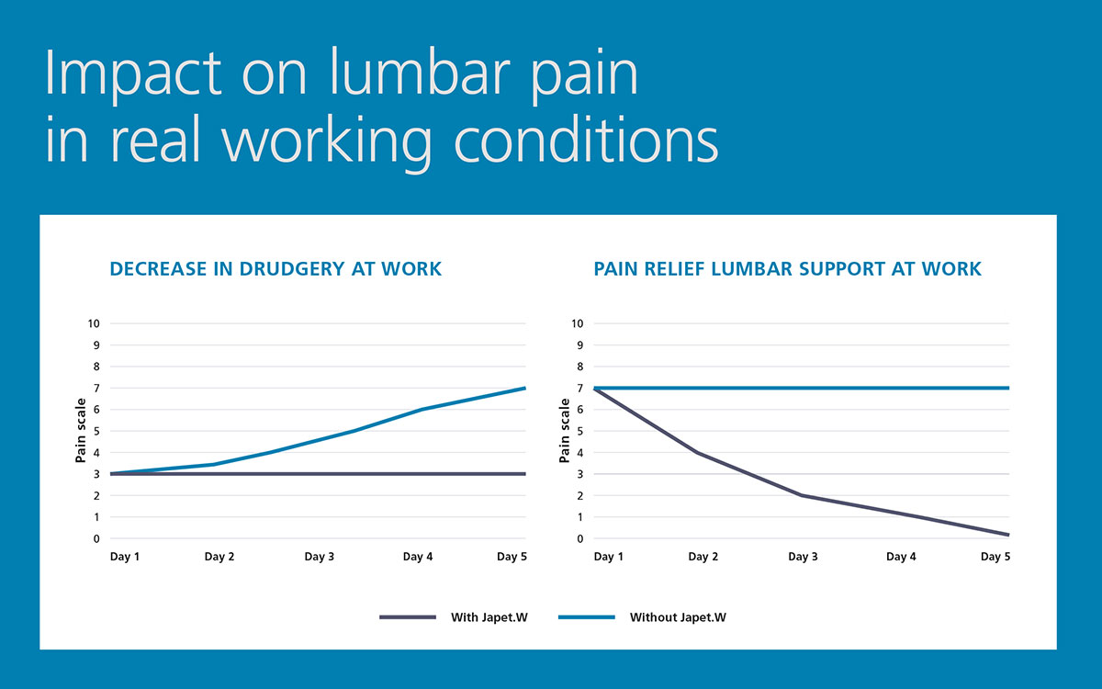
Chart Courtesy of FAULHABER. (Motorised Exoskeleton, n.d.)

A fourth and exciting invention by OpenBionics is the exo-glove. Initially this glove was made for those who have suffered from paralysis or strokes as well as for healthy individuals. Made to enhance the wearers grasping capabilities along with the intuitiveness of the operation, it has a low autonomy, low maintenance as well as low cost. This device evenly distributes the grasping forces over the participating fingers and allows for fine and precise movements. (Exoskeleton Gloves – OPENBIONICS, n.d.)
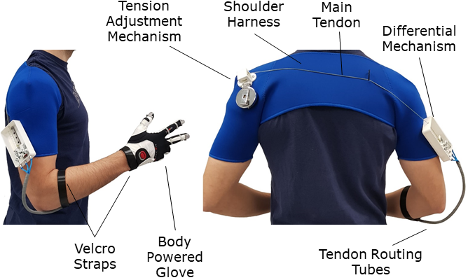
Photo Courtesy of OpenBionics, Exo-Glove. (Exoskeleton Gloves – OPENBIONICS, n.d.)
Another solution to the problem of WRDMS in ultrasound technologists is surgical robots. Robotic surgery has been around since the 1980s with the first use being a brain biopsy. (What to Expect Before, during, and after Robotic Surgery, n.d.) Medtronic, an American medical device company, has come out with a new device called Hugo. Hugo is a portable robotic-assisted surgery device made to be flexible to fit different special needs as well as unique patient needs. (HugoTM RAS System, n.d.) If Medtronic can produce a machine with the capability of performing robotic-assisted surgery anywhere it is needed, why couldn’t the technology be adapted to support the needs of ultrasound technologists? The arm of the device can be remotely controlled by a trained sonographer allowing the exam to be performed safely and without risk to the employee. Also, instead of the need for multiple transducers with lengthy cords that weigh on the sonographer’s hand, add software that can switch between the different transducers needed for an exam. This eliminates the need to carry around multiple transducers and limits the injuries on the sonographer’s body. Finally, this device can be equipped for certain transducers which are designed to go internally and operated by the technologist themselves.

Summary

With the information provided, explained, and sorted through, my goal with this paper was to open the minds of our generation to think outside of the box and come up with a solution to a decades-old problem. Our healthcare workers deserve attention and care in honor of what they do and the sacrifices they make in their work to help make our lives better when we are at our worst. Let’s come together and find solutions to help our medical facilities hold onto their workers and reduce the number of injuries sustained. Every injury is preventable with the right mindset and tools.

References
Harrison, G., & Harris, A. (2015). Work-related musculoskeletal disorders in ultrasound: Can you reduce risk? Ultrasound, 23(4), 224–230. https://doi.org/10.1177/1742271x15593575

‌Murphey, S. (2017). Work-Related Musculoskeletal Disorders in Sonography. Journal of Diagnostic Medical Sonography, 33(5), 354–369. https://doi.org/10.1177/8756479317726767

Workers’ Compensation Costs. (n.d.). Injury Facts. https://injuryfacts.nsc.org/work/costs/workers-compensation-costs/

‌Akbari M, Carriere J, Meyer T, Sloboda R, Husain S, Usmani N and Tavakoli M (2021). Robotic Ultrasound Scanning with Real-Time Image-Based Force Adjustment: Quick Response for Enabling Physical Distancing During the COVID-19 Pandemic. Front. Robot. AI 8:645424. DOI: 10.3389/frobt.2021.645424
Frontiers | Robotic Ultrasound Scanning With Real-Time Image-Based Force Adjustment: Quick Response for Enabling Physical Distancing During the COVID-19 Pandemic (frontiersin.org)

CT scan - Mayo Clinic. (n.d.). Www.mayoclinic.org. Retrieved October 17, 2022, from https://www.mayoclinic.org/tests-procedures/ct-scan/about/pac-203936754

‌CDC. (2019). Work-Related Musculoskeletal Disorders & Ergonomics. Centers for Disease Control and Prevention. https://www.cdc.gov/workplacehealthpromotion/health-strategies/musculoskeletal-disorders/index.html

‌ U.S. BUREAU OF LABOR STATISTICS. (2019, April 12). Diagnostic Medical Sonographers and Cardiovascular Technologists and Technicians, Including Vascular Technologists: Occupational Outlook Handbook: U.S. Bureau of Labor Statistics. Bls.gov. https://www.bls.gov/ooh/healthcare/diagnostic-medical-sonographers.htm

‌ What Is Ergonomics? (2019, April 4). Ergonomics. https://ergonomics.ucla.edu/about

‌ Scanning in Pain. (2009). Radiologytoday.net. https://www.radiologytoday.net/archive/rt111609p24.shtml

‌ Exoskeletons for Medical and Industrial Uses | Ekso Bionics. (2018). Ekso Bionics. https://eksobionics.com/

EVO - The Next Exoskeleton Vest. (n.d.). Ekso Bionics. https://eksobionics.com/ekso-evo/
‌

‌ Levin, D. C., Rao, V. M., Maitino, A. J., Parker, L., & Sunshine, J. H. (2004). Comparative increases in utilization rates of ultrasound examinations among radiologists, cardiologists, and other physicians from 1993 to 2001. Journal of the American College of Radiology, 1(8), 549–552. https://doi.org/10.1016/j.jacr.2004.01.022

‌United States Department of Labor. (n.d.). Ergonomics - Overview | Occupational Safety and Health Administration. Www.osha.gov. https://www.osha.gov/ergonomics

‌Exoskeleton Suits: 20 Real-Life Examples | Built In. (n.d.). Builtin.com. Retrieved November 3, 2022, from https://builtin.com/robotics/exoskeleton-suit
‌Faqs – Comau Mate. (n.d.). Retrieved November 3, 2022, from https://mate.comau.com/faqs/

‌Motorised exoskeleton. (n.d.). Dr. Fritz Faulhaber GmbH & Co. KG. Retrieved November 3, 2022, from https://www.faulhaber.com/en/motion/motorised-exoskeleton/

‌Japet.W – Protect and secure the worker during heavy lifting. (2020, August 20). En.japet.eu. https://en.japet.eu/back-support-exoskeleton/lifting-exoskeleton/
‌What to Expect Before, During and After Robotic Surgery. (n.d.). Verywell Health. https://www.verywellhealth.com/robotic-surgery-4843262
‌Travel Ultrasound Tech Jobs - Make up to $2800/week | Club Staffing. (n.d.). Www.clubstaffing.com. Retrieved November 4, 2022, from https://www.clubstaffing.com/allied-travel-disciplines/imaging-radiology/ultrasound/

‌World Health Organization. (2019, May 28). Burn-out an “occupational phenomenon”: International classification of diseases. World Health Organization. https://www.who.int/news/item/28-05-2019-burn-out-an-occupational-phenomenon-international-classification-of-diseases

‌Mayo Clinic. (2021, June 5). Know the signs of job burnout. Mayo Clinic. https://www.mayoclinic.org/healthy-lifestyle/adult-health/in-depth/burnout/art-20046642

‌HugoTM RAS System. (n.d.). Www.medtronic.com. Retrieved November 4, 2022, from https://www.medtronic.com/covidien/en-us/robotic-assisted-surgery/hugo-ras-system.html?sfdcid=7014O000001JF3G&cid=PPC:BING:%2Balphabet%20%2Bsurgical%20%2Brobot:ras-hugo
‌
Middlesworth, M. (2013, March 21). 5 Proven Benefits of Ergonomics in the Workplace. ErgoPlus. https://ergo-plus.com/workplace-ergonomics-benefits/

‌What is Erognomics? Ergonomics in the Workplace | Humanscale. (2017). Humanscale.com. https://www.humanscale.com/ergonomics/what-is-ergonomics/index.cfm

‌Abbas, T. (2022, July 17). What is ergonomics in the workplace. CMI. https://changemanagementinsight.com/what-is-ergonomics-in-the-workplace/#:~:text=Its%20types%20and%20How%20to%20Improve%20Workplace%20Ergonomics%3F

‌Exoskeleton Gloves – OPENBIONICS. (n.d.). Retrieved November 4, 2022, from https://openbionics.org/exoskeleton-gloves/
‌‌

